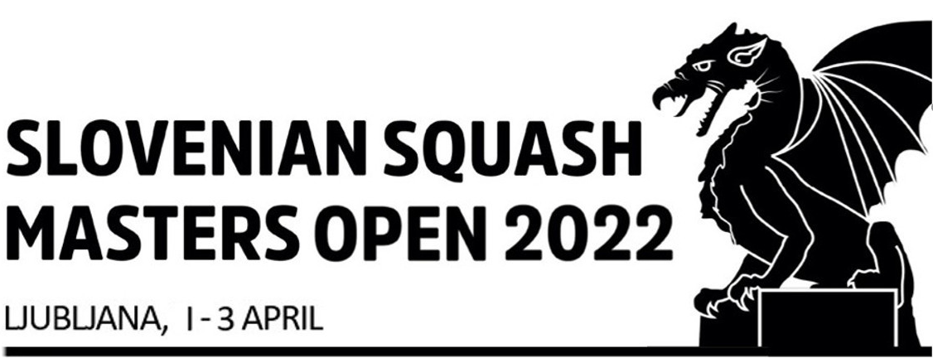Slovenian Masters Squash Open 2022
1st - 3rd April 2022 || smo.squash.si

All information regarding Slovenian Masters Open can be found on http://smo.squash.si/

Contacts
Tournament Director: Tomaž Čampa
Tel: +386 41 362 329
@ tomaz@squash.si

Tournament Referee: Marko Podgoršek Tel: +386 41 533 305
@ mare.squash@gmail.com

Tournament Software Operation:
Tomaž Čampa
Tel: +386 41 362 329
@: tomaz@squash.si

Date, Event category
This European Masters Open event will be held from 1st to 3rd April 2022. The tournament will start on Friday, April 1 at 8.30/9:00 am. The Prize Giving Ceremony takes place at the latest 2.00 pm on Sunday April 3.

Closing date for entries Monday, March 7
Entries may be closed before this date if the maximum number of entries – 150 – is reached.
Any late entries will be on a waiting list and can be used to compensate withdrawals or fill an incomplete draw. They have no guarantee to be accepted. Late entries are only acceptable before the seeding is published at the discretion of the Tournament Director and Masters Sub-Committee in the interest of the tournament.

Venue(s)
Squashland Ljubljana
Pesarska 8, 1000 Ljubljana

Tel: +386 51 455 499
info@squashland.si https://squashland.si/

Categories
Men’s: +35, +40, +45, +50, +55, +60, +65, +70,
Women’s: +35, +40, +45, +50, +55, +60, +65, +70

The TD reserves the right to amalgamate age groups if there are insufficient entries to make a workable draw. Players are only allowed to enter one category.

Eligibility
This event is open to all players who are over 35, 40, 45, 50, 55, 60, 65, 70 on the first day of the event. As specified by ESF, to compete in all ESF Registered events players must hold an active European Squash ID (ESID), which is approved and validated by is MNF and ESF.

Objections to the entry of a player from an MNF must be made without delay after the entry of the player has been published. Players without a European Squash ID (ESID) can register through the ESF website: https://esf.tournamentsoftware.com/member/createorganizationaccount.aspx?id=8B5D0106-404D- 41C3-B2FB-E6FE1BCEAB52

Seeding
The seeding will be carried out by the Masters Committee Seeding Panel using the latest available results and ESF Masters Rankings valid at the closing date and in accordance with the ESF Masters Circuit Guidelines.

Matches
All matches played will consist of the best of five games, under the rules of the WSF. All players are guaranteed a minimum of three matches. The Tournament Organizers will organize plate matches consisting of the best of five games. PAR 11 scoring (to 2 clear points) will be used.

Draws
Maximum draw size: 32 for 3-day event.

Refereeing
Both players will be expected to mark and referee matches, usually the next match on the court, where they played.

Ball
DUNLOP PRO XX.

Prizes
Medals for 1st, 2nd and 3rd place in each age group and other prizes from sponsor. The Prize Giving Ceremony takes place at the latest at 2.00 pm on Sunday April 3.

Insurance
Players enter and play in the tournament at their own risk. Neither the organizers nor the ESF will accept responsibility for any claims including for injury or accident. Suitable insurance must be organized by the player or the participating federation.

Hotels
Reservations can only be made by the tournament organizers.

1st Option Radisson Blu Plaza Hotel ****
Bratislavska cesta 8, 1000 Ljubljana
Tel: +386 1 243 00 00
https://www.radissonhotels.com/en-us/hotels/radisson-blu-ljubljana
(for tournament packages R2, R3 and R4)

2nd Option
BIT Center Hotel **
Litijska 57, 1000 Ljubljana
Tel: +386 1 54 800 55
https://www.bit-center.net/
(for tournament packages B2, B3 and B4)

3rd Option
WUD Hotel ***
Pesarska 6, 1000 Ljubljana
Tel: +386 1 54 800 55
https://www.wudhotel.si/?lang=en
(for tournament packages W2, W3 and W4)

Transport
Players canbe picked-up and dropped off at Ljubljana Airport or Ljubljana main railway station – price of pick-up & drop-off 25 eur.
On all playing days there will be a regular shuttle transfer service between the hotels and the venue.

Entries
The European Masters Circuit is open to all Masters of any nationality provided the player is not banned by his MNA. All entries must be made on the official entry form and sent to: tomaz@squash.si

Payment
The entry fee and package fee, as detailed below, must be paid to the host by the closing date by bank transfer (net of bank charges) to:

Beneficiary Bank: Sberbank d.d.
Beneficiary Bank Address: Dunajska cesta 128 a, 1000 Ljubljana Account Holder Name: Curbis d.o.o.
Account Holder Address: Frenkova pot 52, 1000 Ljubljana IBAN: SI56 3000 0001 4104 030
SWIFT Code/BIC: SABRSI2X
Reference: SMO-2022
Please mark payment clearly with the name of the player and his ESID.

Tournament packages

Package A / € 60 per person
Basic Entry fee (includes the ESF /PFS levy, tournament, t-shirt)
Package Food / € 10 per person per meal
Includes one meal per person at the club (Lunch 12:00 - 14:00, dinner 18:00 - 20:00)
Package Players’ Party / € 20 per person
Players’ party, dinner and a welcome drink on Saturday April 4
Transport from / to Ljubljana airport / € 25 per person

Optional hotel packages – NOTE: ALL PRICES PER PERSON
- Bed & breakfast in selected hotel for selected number of nights
- Radisson guests will be offered shuttle between hotel and venue

Official hotels
- BIT Hotel ** packages – cheaper option & walking distance to club
- WUD Hotel *** packages – wooden designer hotel next to club
- Radisson Blu Plaza Hotel **** packages – located close to shopping centre (10 minutes by shuttle)

Hotel | Room | Guests in room | Detail | 2 nights | 3 nights | 4 nights | Extra night
BIT ** | single | 1 | Package code | B2-1 | B3-1 | B4-1 | 50
 |  |  | Price per person | 90 | 135 | 180
 | double | 2 | Package code | B2-2 | B3-2 | B4-2 | 35
 |  |  | Price per person | 65 | 95 | 125
 | triple | 3 | Package code | B2-3 | B3-3 | B4-3 | 30
 |  |  | Price per person | 50 | 75 | 95
Hotel | Room | People in room | Detail | 2 nights | 3 nights | 4 nights | Extra night
WUD *** | single | 1 | Package code | W2-1 | W3-1 | W4-1 | 70
 |  |  | Price per person | 140 | 205 | 275
 | double | 2 | Package code | W2-2 | W3-2 | W4-2 | 45
 |  |  | Price per person | 90 | 135 | 175
 | triple | 3 | Package code | W2-3 | W3-3 | W4-3 | 35
 |  |  | Price per person | 70 | 100 | 135
 | 4 beds | 4 | Package code | W2-4 | W3-4 | W4-4 | 30
 |  |  | Price per person | 60 | 90 | 120
Hotel | Room | People in room | Detail | 2 nights | 3 nights | 4 nights | Extra night
Radisson **** | single | 1 | Package code | R2-1 | R3-1 | R4-1 | 90
 |  |  | Price per person | 175 | 255 | 340
 | double | 2 | Package code | R2-2 | R3-2 | R4-2 | 55
 |  |  | Price per person | 105 | 155 | 205

Extra night or other arrangements upon request. Packages subject to availability. Considering the limited number of rooms for packages R, W, and B we withhold the right to offer an alternative.

Draws

The seeding lists and time of the first matches for specific age groups will be published 7 days prior to the start date on the ESF Website

Finalized draws for the event will be published on the ESF Website at about 17:00 on the day before the tournament.
Up-to-Date information about this and all other ESF Masters Tournaments will be published regularly in the Facebook group “European Squash Masters”. Please join up today!

ESF regulations & penalties
This event complies with the ESF Masters Circuit Guidelines, a copy of which is available on the ESF website. The tournament will be run under the terms and conditions as set out in ESF Regulations: Code of Conduct - appendix D. The tournament will be run under the terms and conditions as set out in EUROPEAN SQUASH FEDERATION PRIVACY POLICY as published on the ESF website www.europeansquash.com
A late withdrawal is a withdrawal made 2 days or less before the start date of a tournament. Ranking penalties may be applied to the records of players who fail to turn up or who make a late withdrawal not supported by a medical certificate.

Following a withdrawal, fees and packages should be reimbursed as follows:
- Withdrawal up to 30 days before the start date of a tournament: fees reimbursed in full (less bank charges).
- Withdrawal 7-30 days before the start date of a tournament: 50% of fees reimbursed (less bank charges).
- Withdrawal 6 days or less before the start date of a tournament: reimbursement at the discretion of the tournament organizer

If a player:
- Has entered a tournament and fails to turn up, he/she may receive zero ranking points for the tournament
- Fails to play out all scheduled matches for any reason other than illness or injury, he/she may receive zero ranking points for the tournament
- Commits either of these offence for a second time within a 12 month period, he/she may be banned from the ESF Masters Circuit for a period of 12 months

